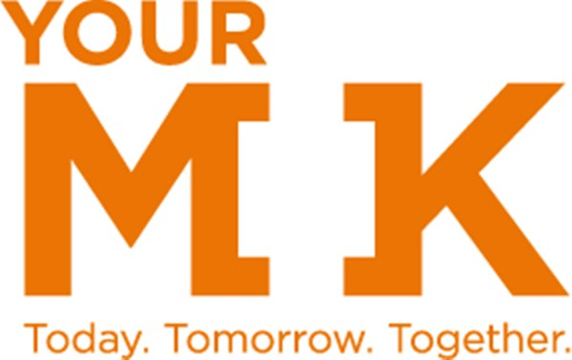

YourMK Regeneration Project Board

Resident Recruitment Pack

March 2018

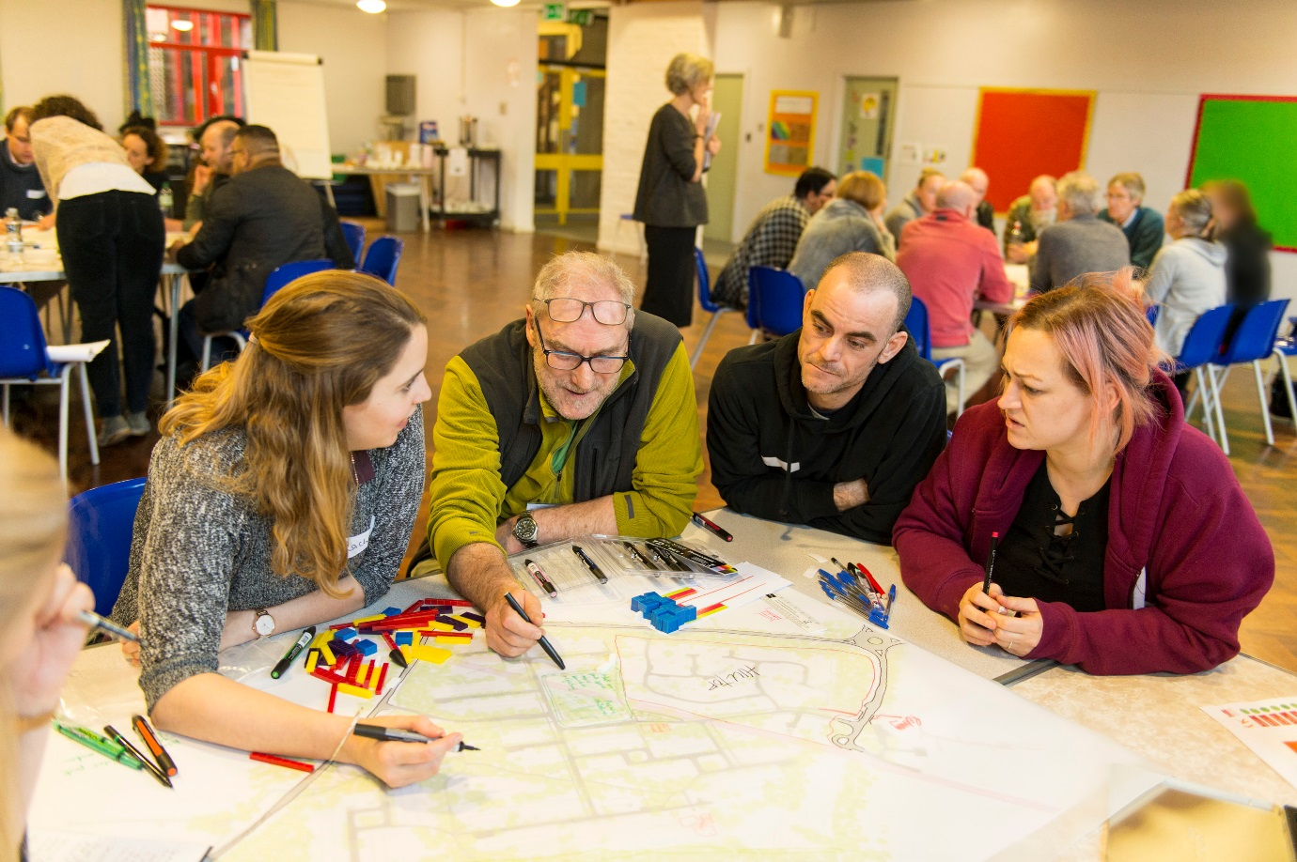

About this pack

This pack contains information about the governance around YourMK regeneration and information for resident board members.

It has been written for any resident who is interested in joining the YourMK Project Board for regeneration where they live.

The role of resident board members is to represent directly impacted residents. They participate in project board meetings so that they can provide a resident perspective in the decision making process; raising issues and ideas from those directly impacted by regeneration.

It is important that resident board members have a good level of understanding about the regeneration process in their area and are open minded and impartial. We want them to be able to work as part of our team to help deliver the best results for residents where they live.

Contents

About YourMK | 3
Our promise and mission | 4
Governance | 5
Project boards | 6 – 7
Resident board members | 8 - 9

About YourMK

In 2015 Milton Keynes Council developed the RegenerationMK Strategy that outlined the aims and objectives of regeneration focused across seven priority areas. These areas are identified as being in the top 15% nationally for multiple evidence of disadvantage and deprivation.
In order to the support the delivery of this strategy, Milton Keynes Council established a partnership organisation with Mears Group to lead on regeneration, combining expertise and financial resources necessary to deliver this effectively.
This partnership is called YourMK.

YourMK Business Objectives 2017-2019

1. Strategic Asset Management | Using high quality data to guide all investment and disinvestment decisions, we will use available funding in the most cost effective manner.
2. Regeneration | To develop a broad range of regeneration activity; delivering a community led and supported plan for each of the priority neighbourhoods.
3. Housing Development | To develop opportunities to provide a range of new dwellings of mixed tenure. The aim is to bring families currently in temporary accommodation through to a more secure tenancy.

What YourMK is |  | What YourMK isn’t
 | An organisation set up and owned by Milton Keynes Council and Mears Group plc. |  | A landlord. Milton Keynes Council remains the landlord for their properties, with no change to tenancy rights.
 | Run by an independent management board, comprised of three representatives from each partner. |  | A profit making organisation. All surpluses must be used to improve or deliver services.

Our Promise

YourMK is a values driven organisation. Our values underpin our mission, organisational culture and the behaviour we expect from our staff.

We promise to be:

- Trustworthy: we will earn the trust of local people. We will consistently communicate and deliver on our promises.

- Responsible: we will be held to account for our decisions and actions; we will pursue excellence in all we do, ensuring we are open, honest, fair, transparent and law-abiding.

- Respectful: we will respect the spirit of residents, communities, and each other; and the unique design and culture of MK. This is so we can develop communities and best practice based on what is already great.

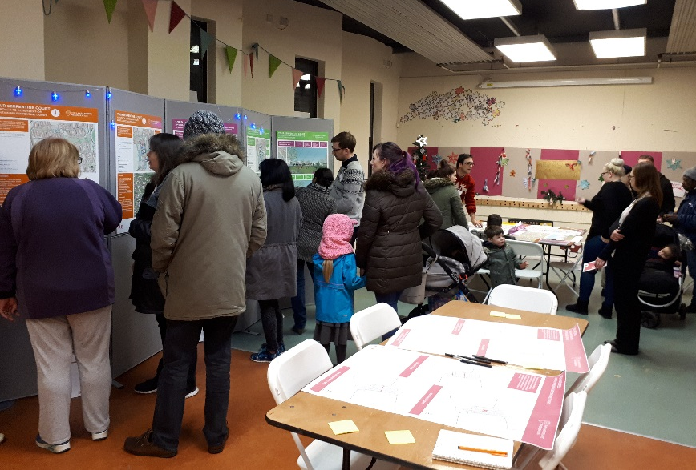
- Involving: we will consult, listen and consider the points of view and suggestions of local people, communities and each other, and respond appropriately to current and future needs.

- Empowering: we will invest in the people and communities of MK, our people and partners. We will build strong relationships to provide residents with choice and the opportunity to influence positive change in their community, and help them take ownership of their future.

Our Mission

Our mission statement sets out what we want to achieve.
Our mission is to establish an outstanding reputation for support and service satisfaction, as well as develop a consistent standard of living for the people of Milton Keynes through:

- Maintaining council properties to the highest quality standards.
- Building quality homes with respect for local environment and culture.
- Supporting the involvement of local people and groups in their community.
- Providing access to appropriate training, education and employment.
- Using significant inward investment to deliver long-term value and benefits to current and future residents.
Our Governance

YourMK has several layers of governance that make sure that the work delivered meets the business objectives and is in line with our values.

YourMK Board
Comprised of three representatives from each partner, and meeting bi-monthly, the YourMK Board is the ultimate decision making body. Its role is to:
- Approve any changes to the Business Plan;
- Provide guidance and approve which new projects should be progressed;
- Act as primary forum for managing YourMK’s performance;

Project Boards
Project boards are set up for each regeneration project. They are chaired by YourMK and are responsible for ensuring the projects are delivering to time and budget, managing risks and addressing issues as they arise. They are decision making bodies.

Resident steering groups
Resident steering groups are set up for each regeneration project. They are comprised of residents ‘directly impacted’ by regeneration; those living in the regeneration area, and are supported by the independent advisor and set their own terms of reference. The groups play an important role in steering both physical and social regeneration, enabling residents’ views to shape the regeneration proposals. They are not official decision making bodies.

Stakeholder groups
Stakeholder groups are set up for each regeneration project and include key stakeholders who are ‘indirectly impacted’ by regeneration. The groups are a means of maximising engagement, consultation and communication with those who live and work within the regeneration area. They are not official decision making bodies.

Please to note decisions are made outside of these meetings where necessary.
Regeneration Project Boards

What are the regeneration project boards?

Project boards are set up for each individual regeneration project. The boards are responsible for ensuring the projects are delivering to time and budget, managing risks and addressing issues as they arise.

Aims and objectives

The project board’s aims and objectives are as follows:

- Establishing and managing the key project activities;
- Identifying and mitigating risks;
- Ensuring the projects and associated activities are delivered to time and budget;
- Ensuring the development and implementation of an effective resident and stakeholder strategy;
- Keeping the project team updated;
- Agreeing detailed next steps.

The project boards report into the YourMK’s board. This means that a summary report of the project is prepared and presented at each main board meeting.

Membership

There are three groups of people who make up the membership of the project boards:

- YourMK staff employed to work on the project;
- Consultants employed to work on the project;
- Residents nominated from the Resident Steering Group within the project;

Meetings

Project boards currently meet monthly. The meetings are not public but the agendas and actions from the meetings will be made public on the YourMK website.

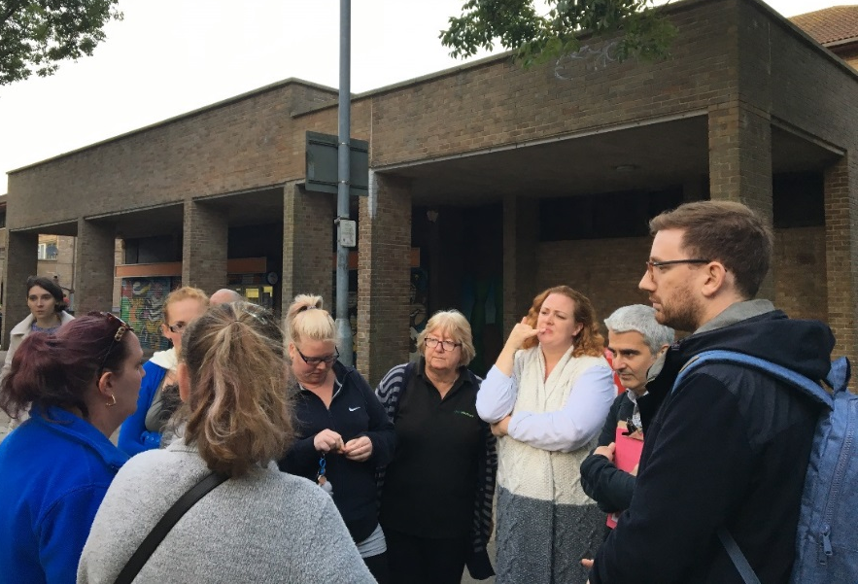

Declaration of interest

It is important to manage actual, potential and perceived conflicts of interests of board members to ensure decisions made at the project boards in the best interest for the whole project and to protect the reputation of the organisations involved.

Project board members are expected to identify and declare any actual, potential or perceived conflicts of interests in matters being discussed at the board.

Confidentiality

Where issues have been identified as confidential or members have disclosed personal information or views in the course of a meeting, such information should not be used for personal benefit nor disclosed to any third party.

Where issues have been identified as confidential or members have disclosed personal information or views in the course of a meeting, such information should not be used for personal benefit nor disclosed to any third party.

Code of conduct

This code sets out the standards of behaviour expected from members when they are attending board meetings and acting on behalf of the board.

The following behaviour is expected from all board members:

- Make contributions that are courteous and constructive;
- Listen to each other, respect other peoples’ views and allow open discussion;
- Make any correspondence sent on behalf of the board available to all members and will not speak or write on behalf of the board without the prior agreement of the group;
- Act in a non-political manner and ensure that personal political activities are kept separate from the business;
- Refrain from confrontational behaviour and verbal and physical abuse at all times;
- Communicate the agreed position of the project board outside of meetings and not individual views or positions, whether one’s own or those of other members of the group;
- Refrain from attending under the influence of drugs or alcohol.

Where a member fails to follow the code, disciplinary action may be taken. In the case of a minor breach, a warning will be issued. Consistent minor breeches may result in the member being asked to leave the meeting.

Serious breaches, including breaching confidentiality, providing false information about the project board, the consultants, YourMK or the regeneration programme, not declaring a conflict of interest and verbal or physical abuse, will result in removal from the board.

Resident Board Members

What does a resident board member do?

The role of resident board members is to represent the end user of regeneration on the project board, that is, the directly impacted residents.

They participate in project board meetings so that they can provide resident perspective in the decision making process; raising issues and ideas from those directly impacted by regeneration.

The role

Resident board members will:

- Attend project board meetings for the area in which they live;
- Carry out the appropriate preparation for project board meetings, such as reading the agenda papers;
- Participate in and contribute to discussions and decisions at project board meetings;
- Participate in training provided for project board members;
- Abide by the code of conduct, confidentiality and declaration of interest sections of the terms of reference, along with all other project board members.

Resident board members are able to claim expenses for travel and childcare that is needed to attend project board meetings.

Requirements

Resident board members will:

- Be a member of the resident steering group for the area being regenerated;
- Live within the regeneration area (as defined by the red line);
- Have a good level of understanding about the regeneration process in their area;
- Be open minded and impartial;
- Be able to participate in and contribute positively to meetings;
- Be able to work as part of a team;
- Have an understanding of equalities and diversity issues.

How much time will it take?

Project board meetings are held in the day, once a month. They usually last around 2-3 hours. There may be preparation for a project board meeting such as reading actions, papers or preparing an update on behalf of the resident steering group.

Recruitment

The resident steering groups of each regeneration area are responsible for selecting resident members for the project board.

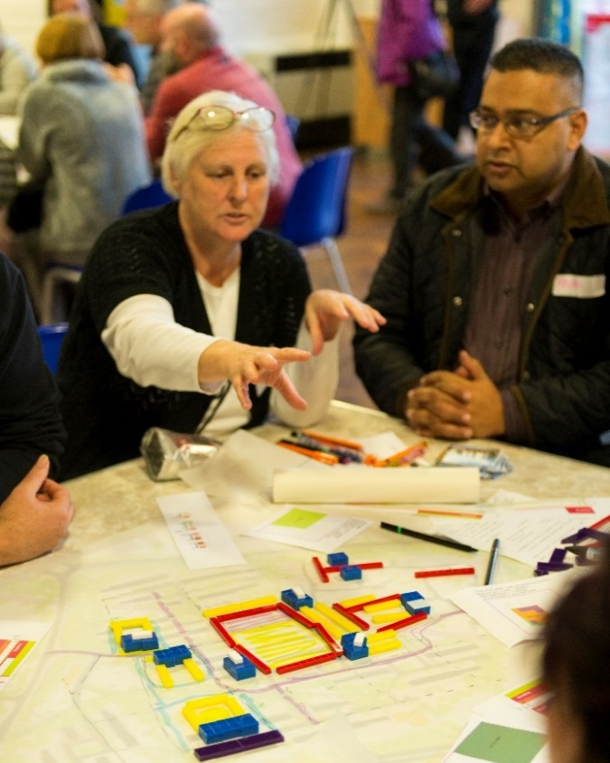
The selection process is as follows:

- The resident steering group must be a formalised group before they can select their representatives. This means having an agreed terms of reference and a selected chair and vice chair.

- The resident steering group can select 1 representative of their group to become the resident project board member for their area and 1 substitute. The substitute will attend a project board when the elected representative cannot attend. The selection process for this will be established and agreed by the resident steering groups themselves.

- Once selected, the resident board members will sit on the project board for one year. Their membership will be reviewed by the resident steering group and the group will agree if they wish to continue or reselect. If, due to unforeseen circumstances such as illness, the resident board member misses 3 board meetings in a row, the resident steering group will be able to review the member’s position and reselect if they wish.

If a resident board member is not able to attend a meeting, they are able to provide a pre-agreed substitute as mentioned above. It is the responsibility of the resident board member to ensure their substitute is up to date with the programme and has the relevant information ahead of the meeting.

Residents will not be eligible to be a project board members if:
- They do not live within the regeneration area.
- They have a history of violence or aggression towards staff and/or other residents.
- Their involvement may cause a conflict of interest due to another role.

If the resident selected by the steering group is subject to court action for tenancy or lease breach (such as for arrears or for anti-social behaviour), or to other relevant legal action, a decision will be made by the project board and discretion will be used to decide their eligibility to join the board.

Interested in becoming a resident board member?

If you are interested in becoming a resident board member and would like more information about the role, you can speak to Tpas, your independent advisor in the following ways:

Drop in: Every Wednesday from 10am-2pm at Spotlight, in Serpentine Court

Free phone: 0800 731 1619

Email: serpentinecourt@tpas.org.uk

